Probability Distributions (Normal, Binomial, Uniform)
Goal: Understand how probability distributions describe real-world data and how to visualize them using Python.

🧠 1. What is a Probability Distribution?
A probability distribution shows how the values of a variable are spread or how likely each possible outcome is.
In simple terms — it tells us “how often we expect something to happen.”

🔹 Types of Distributions We’ll Study
- Normal Distribution – Bell-shaped curve, data around the mean.
- Binomial Distribution – Used for outcomes like success/failure.
- Uniform Distribution – All outcomes equally likely.
We’ll use NumPy, Matplotlib, and Seaborn for demonstration.

🔧 Import Required Libraries
import numpy as np
import matplotlib.pyplot as plt
import seaborn as sns

🎯 2. Normal Distribution
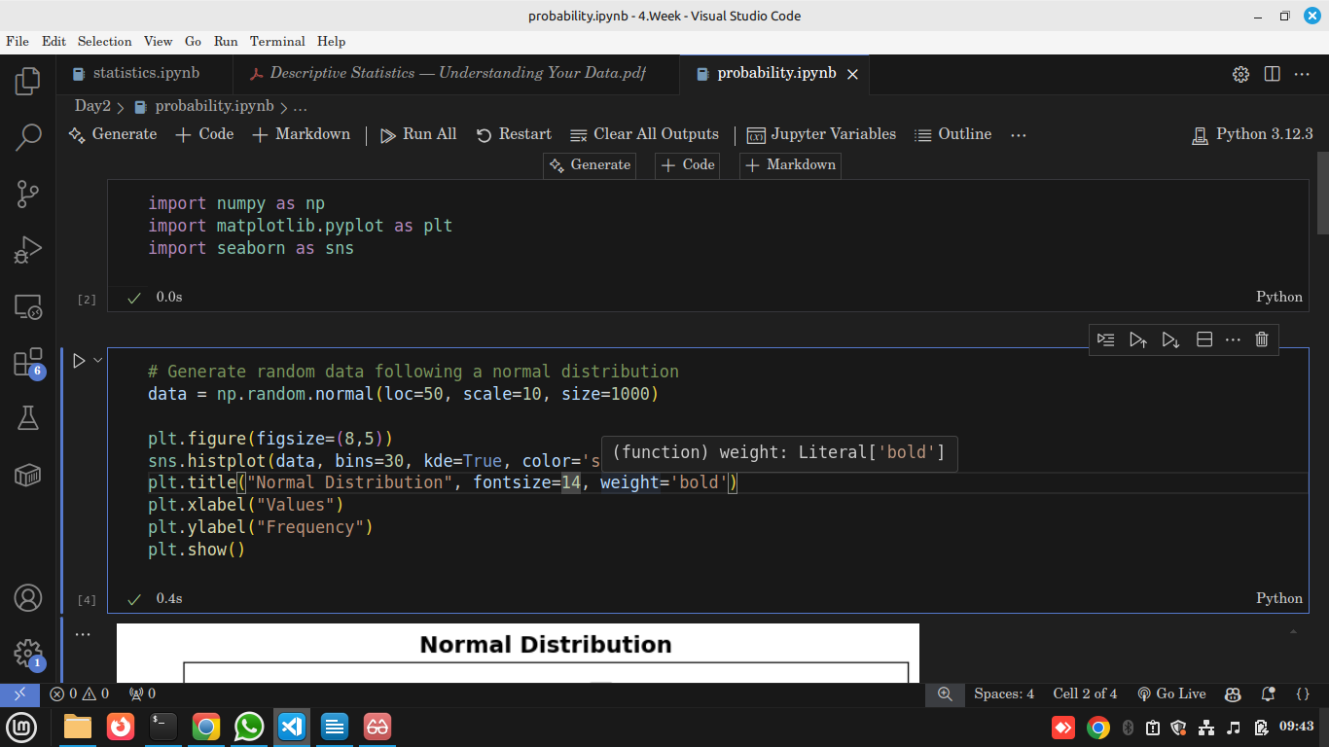

Output
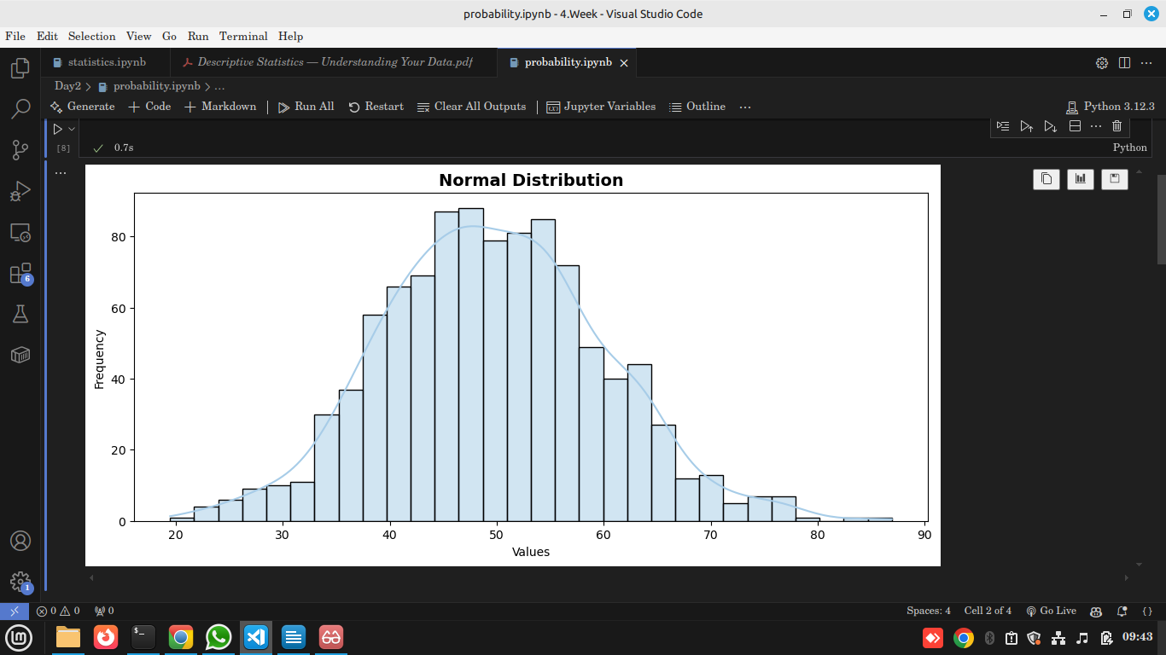

🧠 Explanation:
- loc = 50 → Mean of the data (center of the curve).
- scale = 10 → Standard deviation (spread).
- kde=True → Draws the smooth curve to show the density.
The shape is bell-like — most values cluster around the mean (50), and fewer appear as you move away from it.

📊 Insight:
This is one of the most common distributions in nature and business.
Examples:
- Human height
- Exam scores
- Daily temperature
Why it matters:
The normal distribution helps analysts predict probabilities — for example, estimating how many students will score above average in an exam or how likely a machine part will last beyond a certain time.

🎯 3. Binomial Distribution

🧩 Code:
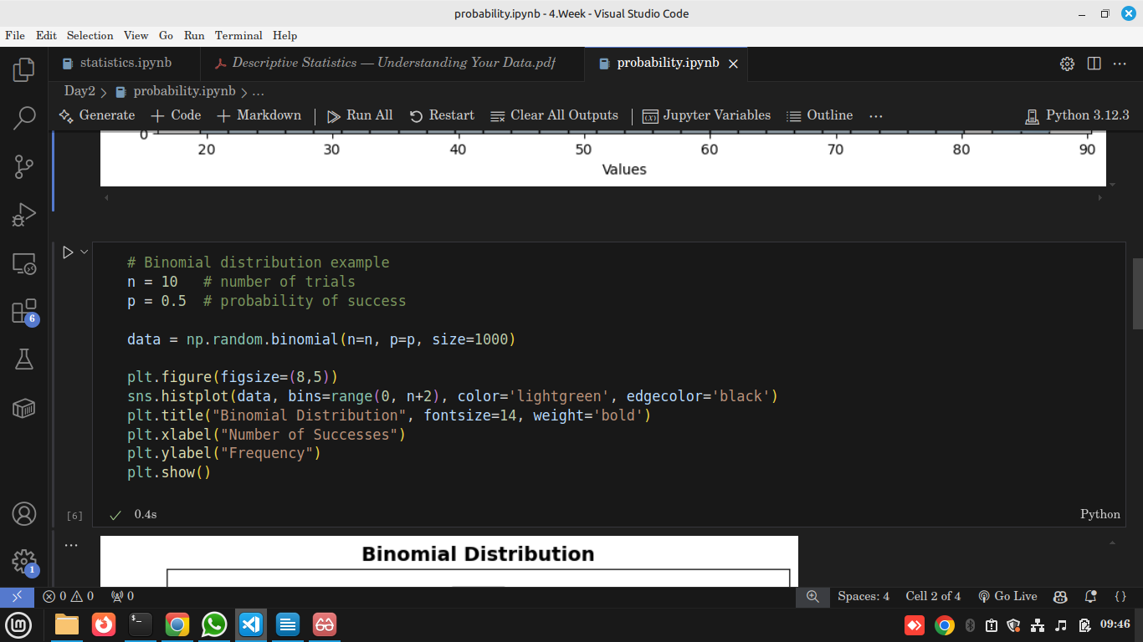

Output
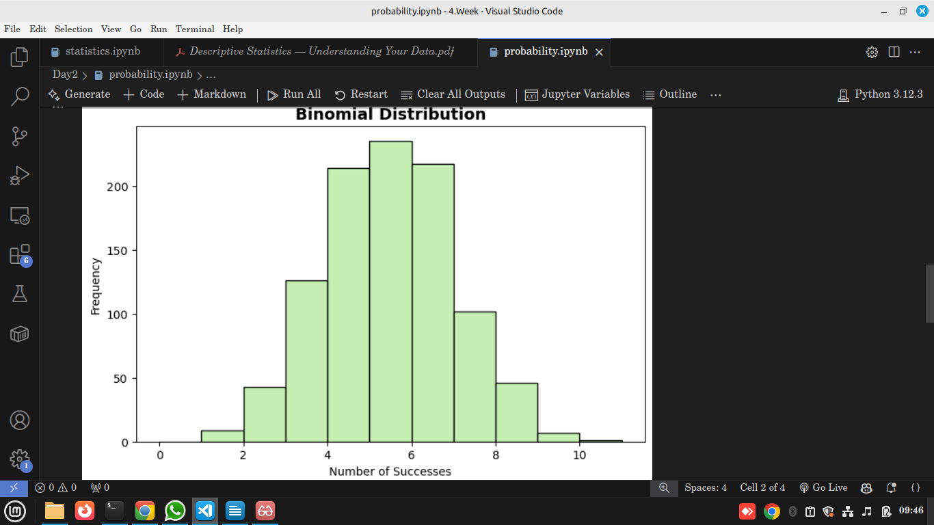

🧠 Explanation:
- n = 10 means each trial has 10 attempts (e.g., tossing a coin 10 times).
- p = 0.5 means the chance of success (heads) is 50%.
- The most frequent result (the peak) occurs around n × p = 5.
This distribution is discrete, meaning it counts how many successes occur.

📊 Insight:
Used when outcomes are yes/no, success/failure, or click/no-click.
Examples:
- Number of customers who make a purchase out of 10 visitors
- Number of defective items in a batch
- Number of students who pass an exam
Why it matters:
Binomial distribution is critical for predicting probabilities in marketing, manufacturing, and medicine — any scenario with repeated binary outcomes.

🎯 4. Uniform Distribution

🧩 Code:
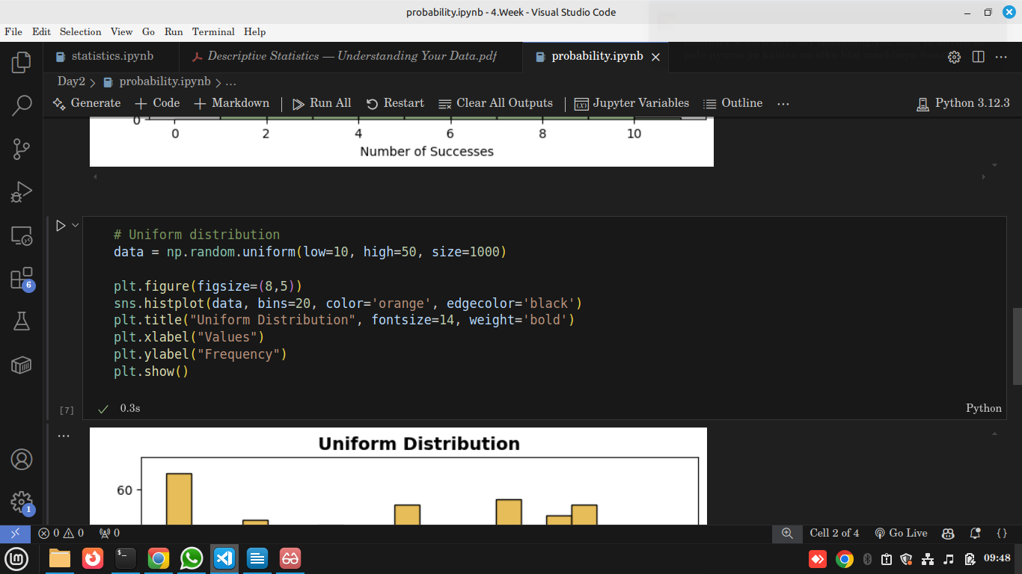

Output

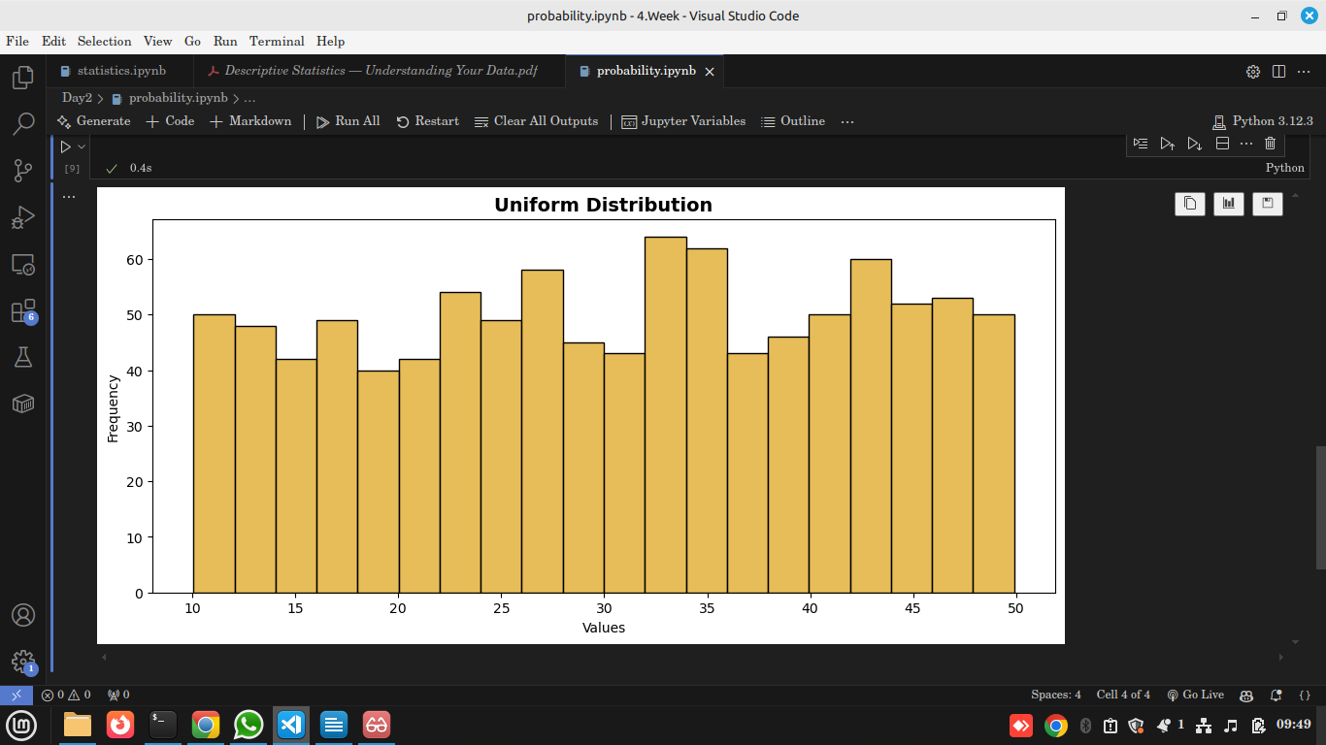

🧠 Explanation:
- low = 10, high = 50 means all numbers between 10 and 50 are equally likely.
- The histogram shows a flat pattern — each range has roughly the same frequency.

📊 Insight:
Used when randomness or fairness is required.
Examples:
- Random number generation
- Shuffling playlists
- Selecting random samples in research
Why it matters:
Uniform distribution ensures fairness in games, experiments, or simulations where no bias should exist.

📈 5. Comparison of the Three Distributions
Distribution | Type | Shape | Real-world Example | Key Use
Normal | Continuous | Bell curve | Heights, IQ, temperature | Natural and human behavior modeling
Binomial | Discrete | Stepped | Coin toss, pass/fail | Modeling success/failure rates
Uniform | Continuous | Flat | Random draws, fairness | Random sampling and simulations

💡 6. Real-world Importance
when you plot or analyze a normal distribution in a business setup, you’re not just looking at the pretty bell curve — you’re looking for patterns, thresholds, and probabilities that guide decisions.
Here are practical, real-world insights you’d look for 👇

💼 1. Understanding Customer Behavior
If your data shows customer spending follows a normal distribution:
- 📊 Mean (Average spend): tells you what a typical customer spends — e.g., KSh 1,500 per visit.
- 🎯 Standard deviation: shows how consistent spending is.
  - Low σ → customers spend almost the same every time (stable).
  - High σ → customers vary widely (some spend a lot, some spend very little).
- 💡 Insight:
You can segment customers — e.g., target high spenders for VIP programs and low spenders for discounts.

📦 2. Product Quality Control (Manufacturing)
Let’s say you measure the weight of packaged goods (e.g., 500g flour packets):
- If the weights form a normal curve centered around 500g:
  - ✅ Most products are close to the standard (good).
  - ⚠️ If the curve shifts left (mean < 500g): your machine is underfilling.
  - 🚨 If the curve widens (large σ): your process is inconsistent.
Insight:
The normal distribution helps detect production drift early — saving costs and preventing complaints.

🧍 3. Employee Performance Analysis
In HR or management:
- Suppose you collect employee performance scores.
- They often follow a normal distribution — most employees perform at an average level, few are very high or low.
Insight:
- The mean gives the “typical performance level.”
- The tails identify top performers (for promotion) and low performers (for training).

💰 4. Sales Forecasting
If your daily or weekly sales volume follows a normal pattern:
- You can predict the range of expected sales (e.g., 68% of the time, sales will be within ±1σ).
- Helps plan inventory — avoid overstocking or running out.
Example:
If mean = 10,000 KSh, σ = 2,000
→ 68% of days sales will be between 8,000 and 12,000.
✅ This helps with staffing, supply ordering, and setting realistic targets.

📞 5. Customer Wait Times or Service Durations
In customer service or call centers:
- If call durations or waiting times are normally distributed,
  - The mean shows average service time.
  - Long right tail may indicate some customers wait too long → you can fix staffing or processes.

📈 6. Marketing Campaign Results
If you test new campaigns and measure conversion rates:
- Normal distribution can help you find what’s typical performance.
- Outliers on the right (very high conversions) can reveal strategies worth repeating.

🧩 7. Assignment
Use Python and Seaborn to:
- Plot a Normal Distribution with mean = 100 and std = 15.
- Plot a Binomial Distribution with n = 20 and p = 0.3.
- Plot a Uniform Distribution between 0 and 1.
- For each:
  - Describe the shape.
  - Find the mean and variance using NumPy.
  - Give one real-life example.

🧭 Summary
- Normal Distribution: Data clusters around the mean.
- Binomial Distribution: Measures number of successes in fixed trials.
- Uniform Distribution: Equal likelihood for all outcomes.
- These form the foundation of statistical modeling, allowing data scientists to simulate real-world randomness, estimate probabilities, and make predictions.

